**Marketing management assignment 2 :**

**Group member :**

**JAHANZAIB ( k213361) AREEB UL HAQ (k213346) SHAHMIR (k21-4583)**

**Syed Muhammad Huzaifa (21k-4948)**

**TASK 1**

**JOB: Product Developmnent Director**

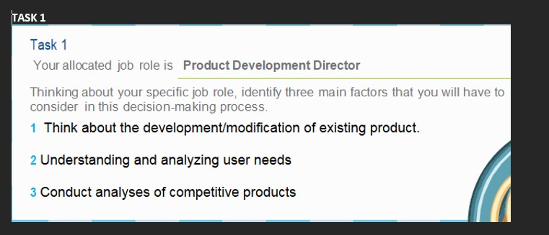

JOB: Finance director:

1. Development of financial report and provide financial advice to most beneficial financial decisions and also make long term financial planning.
2. The other job of finance director is to take investment and financial decisions and must be able to analysis the financial data to evaluate the performance of employees or workers. 3) forecasting of financial outcome/result is another most important job of finance director and it is the responsibility of finance director to continuously monitor the liquidity qnd optimize the flow of
3. Funds.

JOB: Marketing Research Analyst

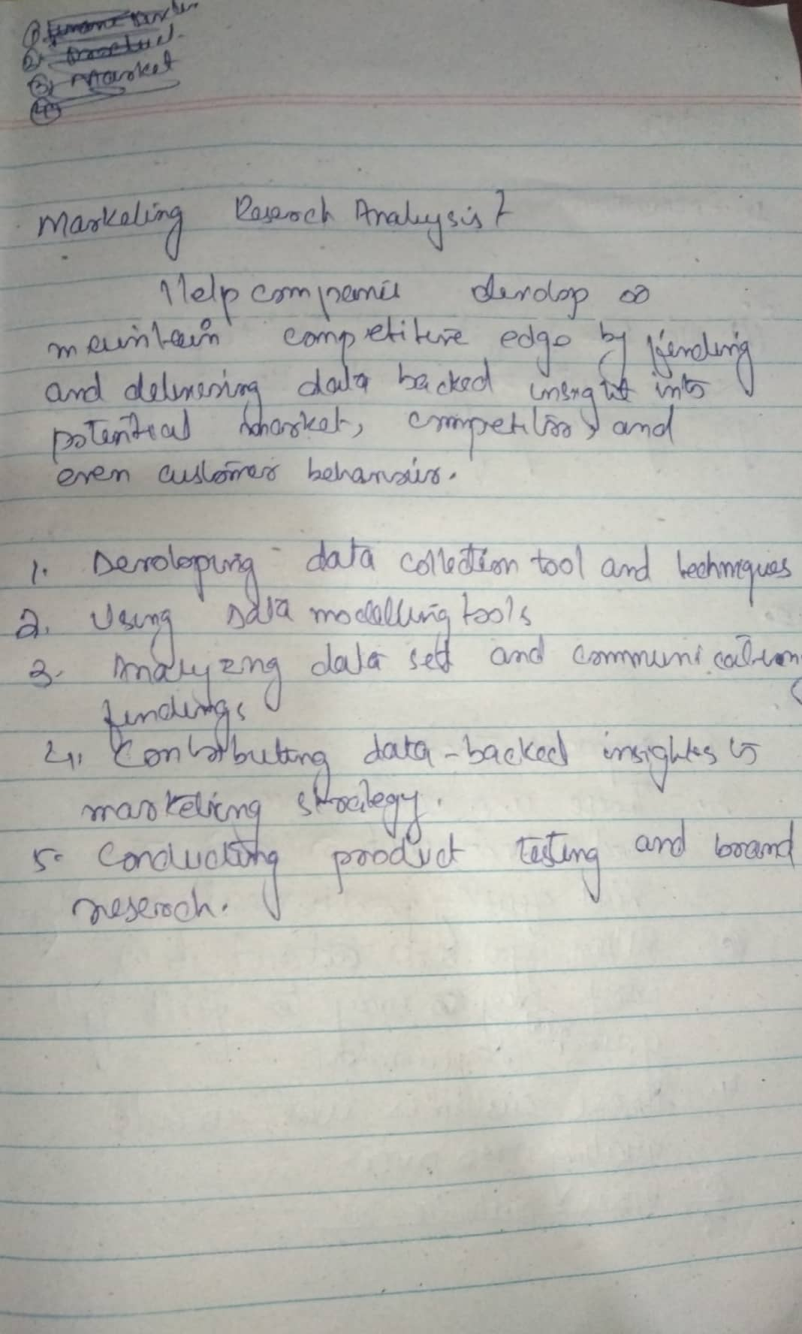

JOB: Marketing Director

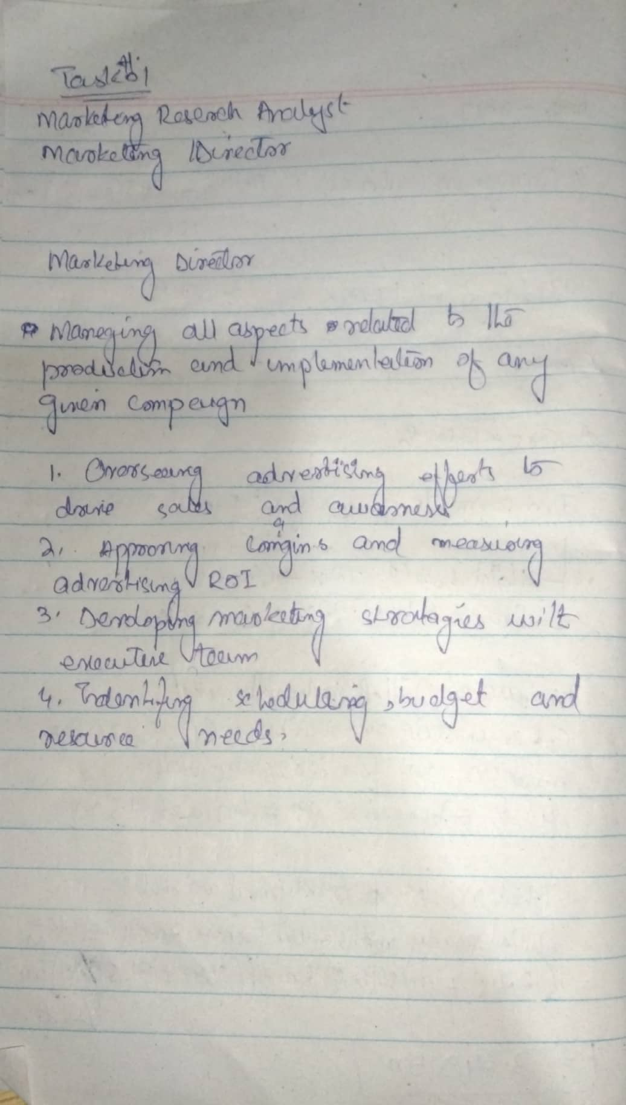

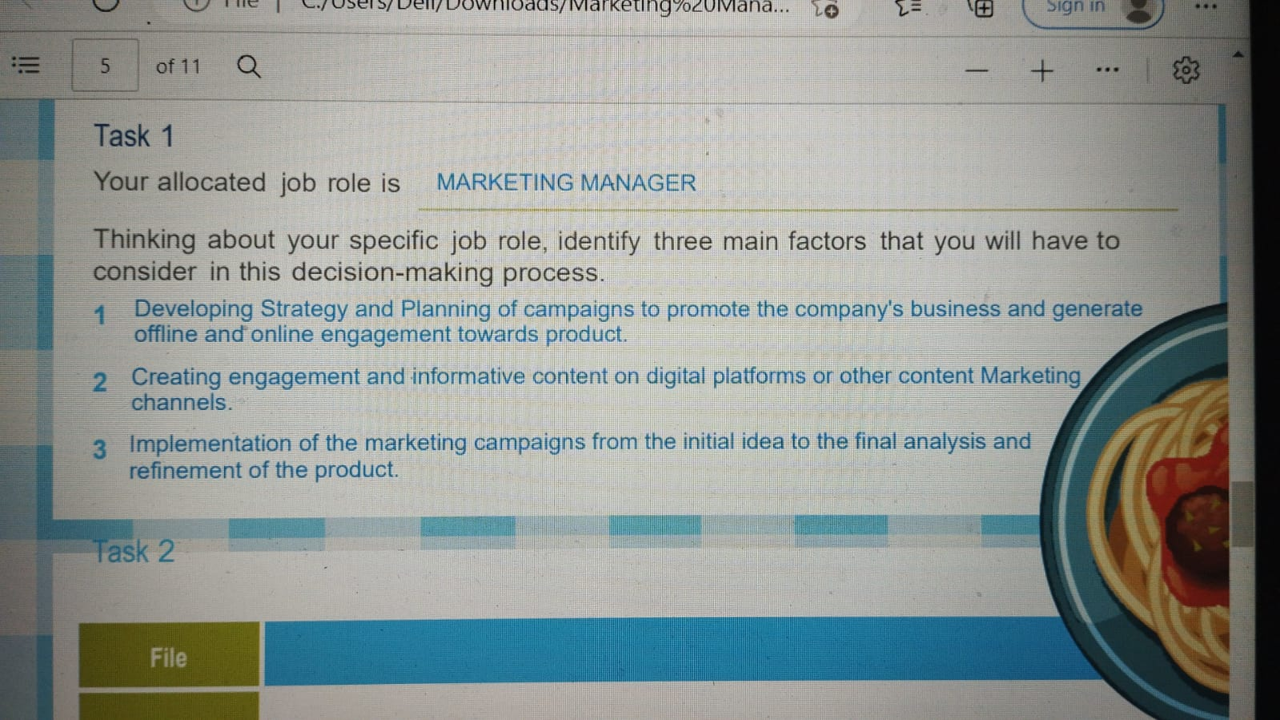

**TASK 2**

**CALCULATIONS:**

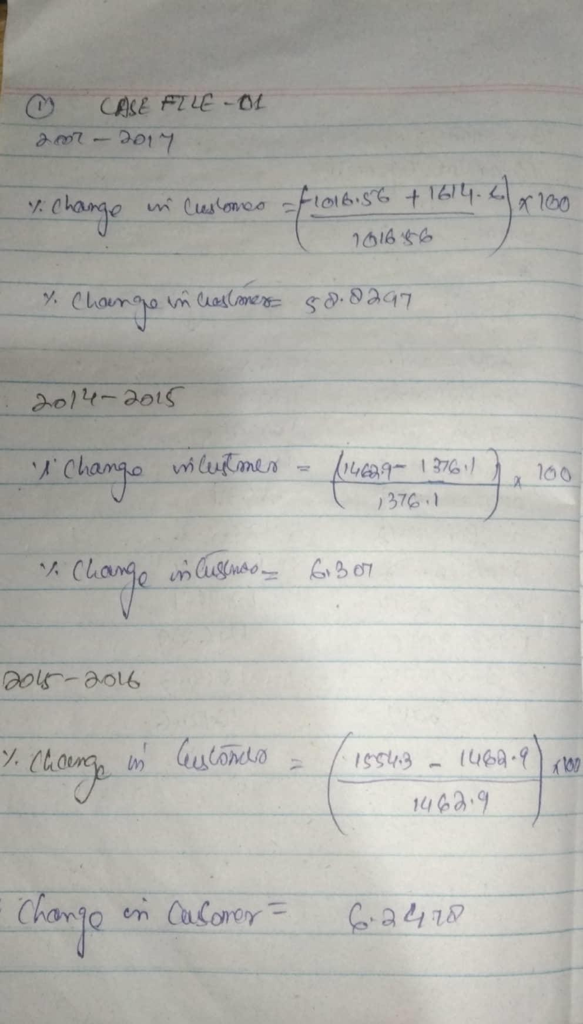

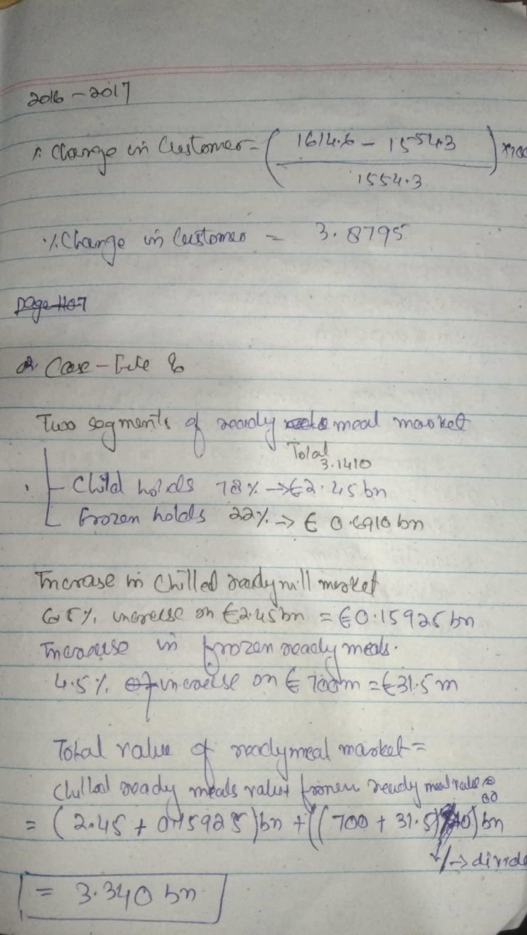

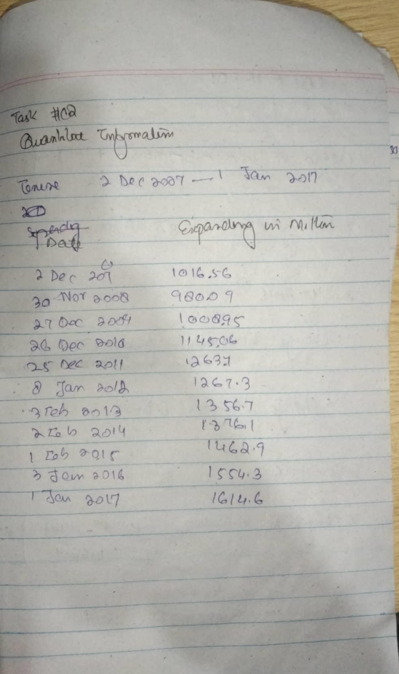

|  |  |
| --- | --- |
| **FILE** |  |
| **1** | **58.83% customer increase in ten year in chilled ready meals and main**  **meal.** |
| **2** | **Main target audience is younger consumer and farm-food products are fast growing grocer in 2014 and Iceland too teamed up with slimming world in 2015**  **to sell a new range of frozen ready meals.** |
| **3** | **Healthy food products are main customer/consumer focus and**  **government also create impact towards healthier eating.** |
| **4** | **The trend changing from eating out to dining in with the specific preference for higher and convenience lines(premium ready meals) as a result premium ready meals becomes cash conscious while frozen and**  **chilled market was in decline.** |
| **5** | **Main focus on market research and product development.** |
| **6** | **Company is maintaining its quality to stick their position in the market and the customer need is changing as premium product provides convenient meal solution which give it major rise in market value;however, frozen sector rises around 4.5% and chilled sector rises**  **around 6.5%** |
| **7** | **Waitrose penetrates current market through a new line called waitrose 1 which consists of 520 items. This market is already acquired by Aldi and**  **Lidl.Waitrose also wants to achieve £500m target.** |
| **8** | **In Russia due to economic crises, People's disposable income decreases so people try to cook food in their home.**  **In the USA, due to wealth increases and change in tests of them they mainly prefer restaurants or call and get dining out products**  **In France, people try to use their cooking time by doing other activities so they make the habit of fast available meals which increase the market**  **of chilled ready products etc.** |

**TASK 3**

|  |  |  |
| --- | --- | --- |
| **Ready meal** | **PROS** | **CONS** |
| Children |  |  |

|  |  |  |
| --- | --- | --- |
| Diet |  |  |
| Premium |  |  |
| Family |  |  |

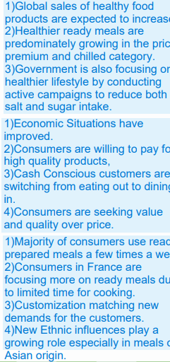TASK 4

* 1. PREMIMUM:
  2. I) we target to the disposable income customer which gives much profit then other stratagies
  3. 1) disposable income
     1. Those who wants ready meals and did not want to cook or need meal quickly
     2. It is the very easiest way to full fil your meal requirements when you are out of your home
     3. Those customer who wants quality over prices
  4. DISPOSABLE INCOME :

BECAUSE IF THE CUSTOMER HAS DISPOSABLE INCOME THEN WE ABLE TO TARGET THE OUR DESIRED MARKET